LAPRAK

AZTECA CHELSY_1203230062

SOAL PERTUKARAN KARTU

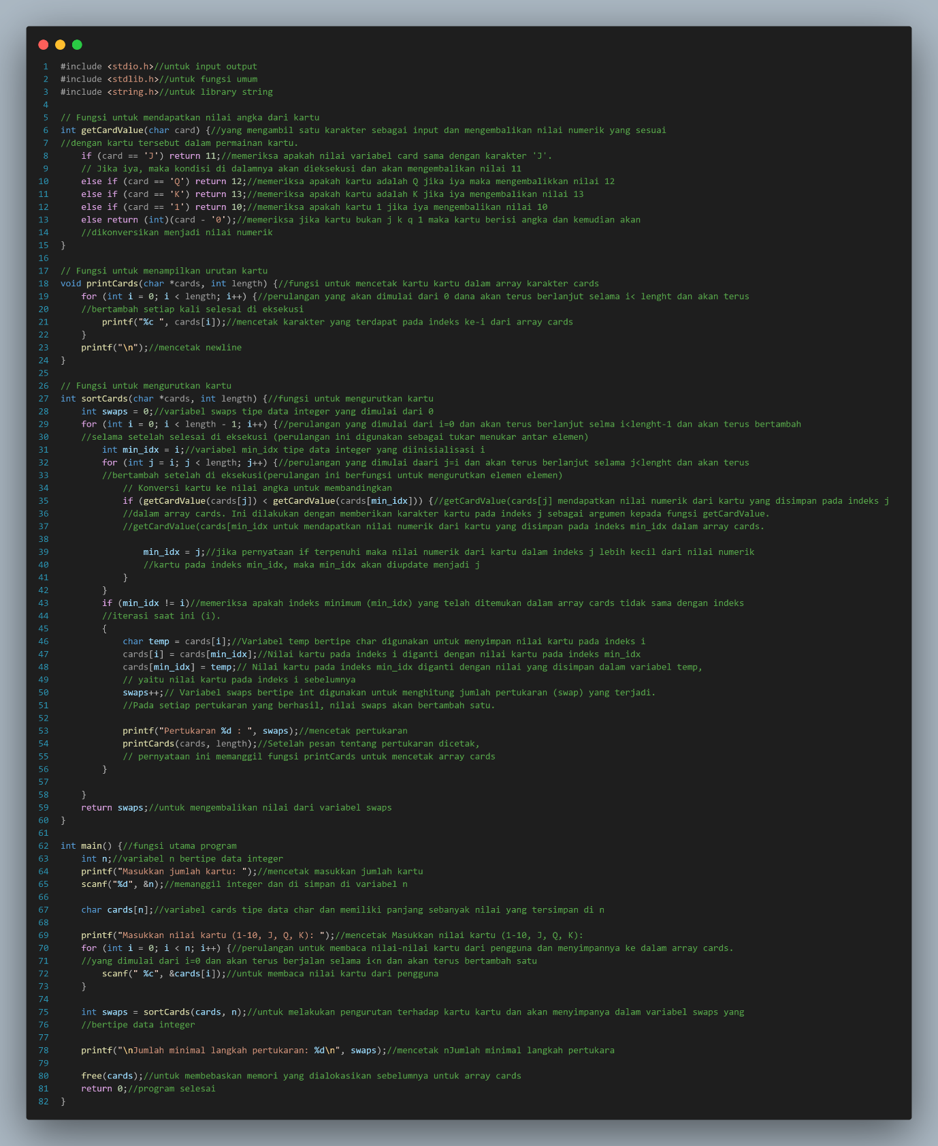

**HASIL OUTPUT**

PS C:\Users\CHELSY> cd "c:\Users\CHELSY\.vscode\" ; if ($?) { gcc tempCodeRunnerFile.c -o tempCodeRunnerFile } ; if ($?) { .\tempCodeRunnerFile }

Masukkan jumlah kartu: 8

Masukkan nilai kartu (1-10, J, Q, K): 9 4 2 J K 8 4 Q

Pertukaran 1 : 2 4 9 J K 8 4 Q

Pertukaran 2 : 2 4 4 J K 8 9 Q

Pertukaran 3 : 2 4 4 8 K J 9 Q

Pertukaran 4 : 2 4 4 8 9 J K Q

Pertukaran 5 : 2 4 4 8 9 J Q K

Jumlah minimal langkah pertukaran: 5

PS C:\Users\CHELSY\.vscode>

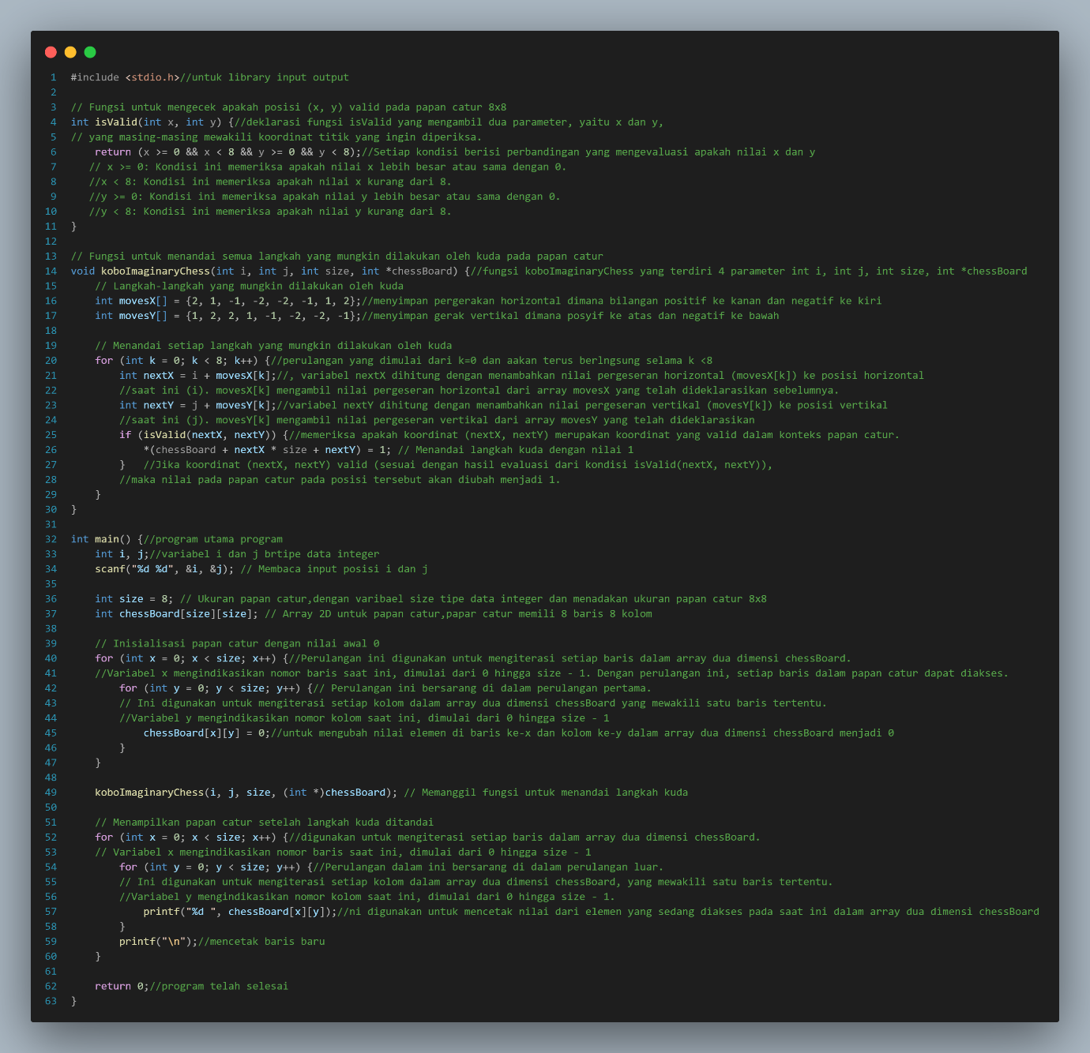

HASIL OUTPUT

PS C:\Users\CHELSY> cd "c:\Users\CHELSY\.vscode\" ; if ($?) { gcc tempCodeRunnerFile.c -o tempCodeRunnerFile } ; if ($?) { .\tempCodeRunnerFile }

2 2

0 1 0 1 0 0 0 0

1 0 0 0 1 0 0 0

0 0 0 0 0 0 0 0

1 0 0 0 1 0 0 0

0 1 0 1 0 0 0 0

0 0 0 0 0 0 0 0

0 0 0 0 0 0 0 0

0 0 0 0 0 0 0 0

PS C:\Users\CHELSY\.vscode>